General Mills Cooking Demo
&
Tour of US Foods Facility
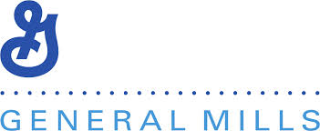
Sponsored by US Foods

AHF-NY invites you to
“Enhancing Your Retail Sales and Creating Snacking Solutions”
Lead by General Mills Corporate Chef Gilles Stassart, CEC, CCA
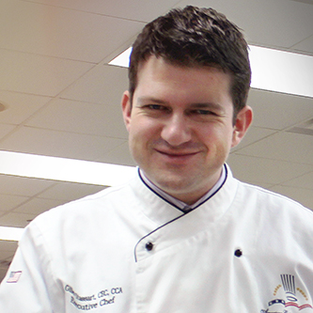

Thursday April 30, 2015
Pick up at Manhattan VA 9:30 a.m. sharp.
Lunch will be served.

This event is free and open to AHF-NY Operator Members only.
Space is limited.
Register online at www.ahfny.org

Transportation provided to and from US FOODS
1051 Amboy Avenue, Perth Amboy, NJ 08861

Directions to Manhattan VA
423 E 23rd Street at 1st Ave
Phone: (347) 675-5560
Take #6 train to 23rd street. Walk or take cross town M-23 bus to 1st Ave and E 23rd street.

